**Document**

**For**

***LAP SOFTWARE FOR HANDICRAFT***

Version 1.0

March 19, 2018

**Prepared by:**

**JAY SONI**

AMAZING TECH

1. Product Uploading with proper detailing
2. Product scan through App (QR Code)
3. Purchase Order issue
4. Purchase Order Follow-up
5. Manage Supplier and Buyers detailing
6. Product Pricing
7. **Product Add/Edit/Manage**

User can add /edit/ and manage the product through admin panel.

Following are the product details:

1. Product id ( programing use)
2. Product Title
3. Product description
4. Product Height
5. Product Weight
6. Product Length
7. Product CBM (calculate through Height Width Length)
8. Product CBF (calculate through Height Width Length)
9. Special Instructions
10. Special Instructions File (if any)
11. Assembly instructions
12. Assembly instructions file (if any)
13. Product Finish Type (Multiple Options)
14. Images (Multiple Images)

First user will add its products to applications. Each product has different values and specifications. We have to manage/Calculate Products CBM and CBF from its height width length. Formula for calculating CBM and CBF will be provided by client which we have to integrate in application.

Here we have to manage user who can add the product but can’t edit the product. Products can managed (edit / removed) by admin only. Each product will have unique product id to identification which is also used officially. We have to set option to upload multiple images and order to arrange the images.

**Product Parts**

1. Id (for programming use only)
2. Product id (Foreign Key)
3. Part Title
4. Part image
5. Part Quantity
6. Status

Any product may have different parts. Like Tables may have constructed through different parts legs, table base, table top etc. We have to manage these parts along the product management. Managing products parts is also important because it will be also used when we will place order to suppliers.

Rest details will be updated.

**Manage Buyers & Suppliers**

1. Id
2. Name
3. Contact number
4. Country (in case of buyer)
5. Address
6. Email address
7. Type (0 = buyer, 1= supplier)
8. Work speciality (this will be used in case of supplier. Speciality in Wood work, Iron work and other)
9. status

We have to manage buyer (who is placing order) and supplier (to whom we are giving order to manufacturing). This data will be used when we will manage purchase order (PO). When taking order from buyer and distributing order to supplier.

**Purchase Order Management :**

**Here purchase order has two scenarios.**

1. **Buyers Purchase Order**: Taking Buyer order in updating in application. Once the user has uploaded products in application. Then the admin can take/insert orders in application. Order example will be like this. Buyer XYZ has placed order 100 tables (Proudct code Table001) , 200 Chairs (Proudct code Chair010) , 500 Café Tables (Proudct code Table008) and then order placed in application with some deadline to complete the order on time and this deadline and timing will be managed. Suppose the above order’s deadline is 1 month then after placing the order every week a reminder email will be sent automatically to admin staff to take follow-up of the order.
2. **Supplier Purchase Order:** Once the above order is placed, then admin staff will create supplier purchase order for above placed order. Above order can be distributed to different supplier. Like Above product code Table001 which is a table and this table is made up of two sections **Top of Table** and **4 legs of table**. So admin can place order to supplier XYZ to create 100 Tops of table and the rest Section two which is **4 legs** each table will be placed to supplier ABC for manufacturing. The will be placed with a deadline date and proper follow up system like we created for buyers. Once the order for supplier is placed then a SMS will be send to supplier for collecting the PO and start working on that order.

**Product Pricing**

Work in progress….

**iOS App Work**

Login through app to admin and other member staff. Options to scan QR code and get product details on app. Option to share the product via email. Options to add buyer order via App. Showing the products to buyer on mobile and then adding the order through app to application.

# Welcome Page

After login, this is first welcome page where User will be redirect. This page shows welcome greeting along with User’s name, current day and time - date.

The next section below the welcome screen, there will be three tabs entitled as :

1. **Dashboard**
2. **Hotel Info**
3. **Calendar**
4. **Finance**

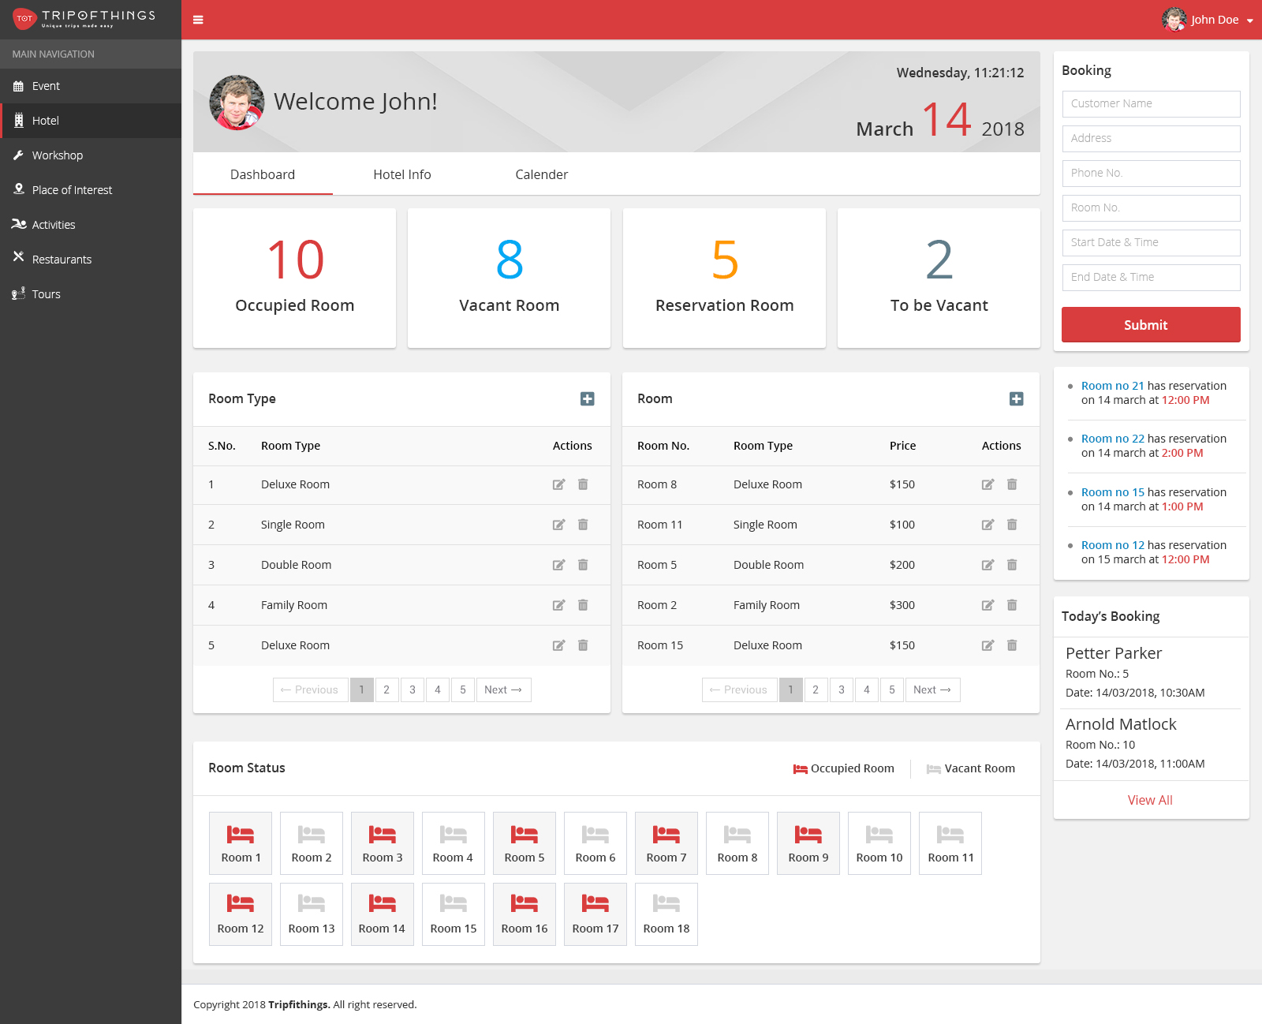

Image 1 : Dashboard

This module have some common modules which include with all main modules, these modules are defined as following sections :

**Top bar :** Top header bar will show the name of the application along with company’s logo. It will also show the profile picture of logged in User/Admin.

**Navigation Bar :** The left side section will contain all navigation links which are connecting to other modules existing in application.

**Booking :** This section will book a room in the hotel for a given date range. The booking form consist of following fields :

* **Customer Name** : Full name of visiting person.
* **Address :** Complete address of concern customer.
* **Room No. :** It will be the vacant room no. to be book.
* **Start Date & Time :** From the date and time when the room is being occupied.
* **End Date & Time :** Till the date and time when the room is going to be vacant.

After submit it will save the record and mark the respective room as occupied. When the **Start Date** & **End Date** are future date then this booking will be mark as **Reservation.** Here both start & end date will be either current date or future date.

**Reservation Notice board** : This is the next section under the **Booking.** Itwill show all upcoming reservation .The notice will be consist of room no. , date & time of reservation.

**Today’s Booking List :** This section will show the all those reservation detail which booked for current date. It will show the customer’s name, room no. & booking date-time.

By clicking on **View All,** it will show a popup containing all the booking happening on current date. This popup will show the **Customer Name, Room Number, Phone Number,** booking’s **Date From To** & **Action -** No Show as link on non-cancelled booking. User can do cancel that particular record by clicking on **No Show** when customer not appear on booking date.

Pagination will be there at bottom of this pop-up to move on next & previous records

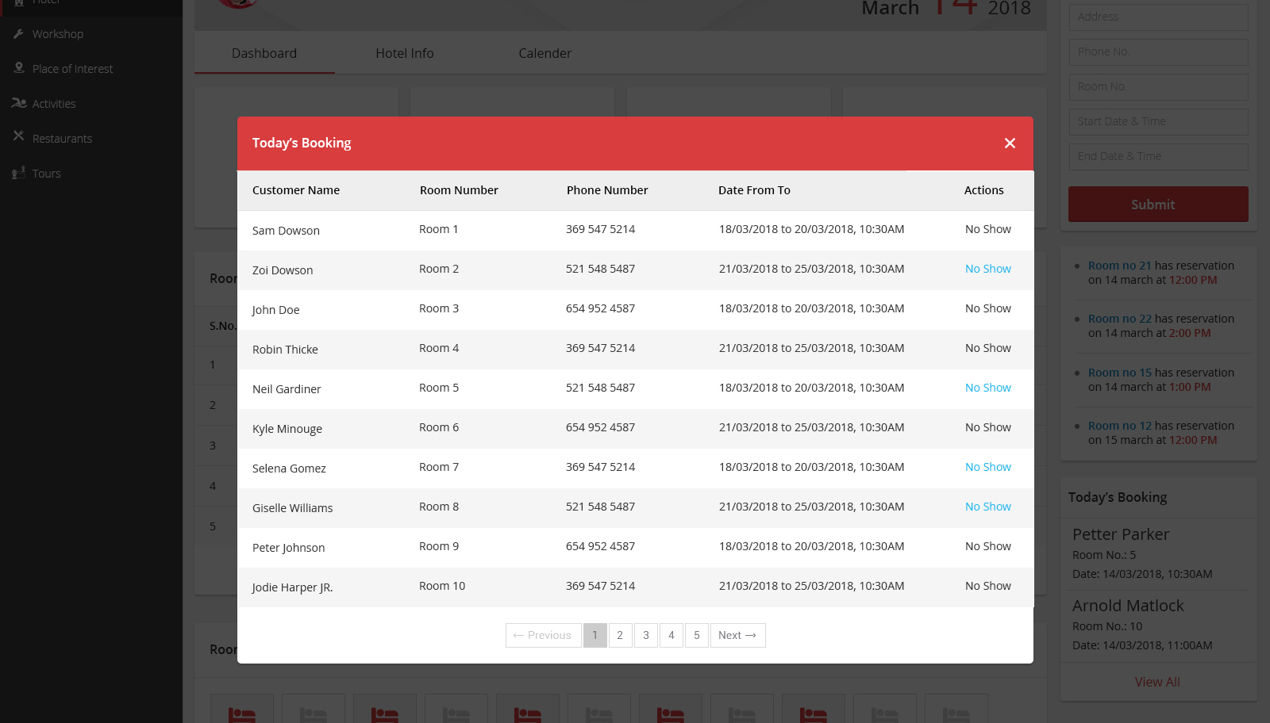Image 2 : Room Type

# Dashboard

## Hotel Room Statistics Tiles

There will be four tiles having the information belongs to the rooms.These tiles show the statistics of hotel room as of current date. It will show the following information :

* **Occupied Room :** No. of rooms which are in-used as of current date.
* **Vacant Room** : No. of rooms which are free on current date.
* **Reservation Room :** No. of room for which booking is occured or on going on current date. These room are other than vacant room.
* **To be vacant** : No of room which are occupied but going to be vacant on today.

## Room Type

This panel will contain the list of all categories of rooms exist in hotel. This list will show the category name & edit & delete actions. By clicking on **+ (plus icon)** at right top corner, it will show a form to add a new category. The form will consist of a single input text field, where user can defined the name of category.

Same like this on clicking on edit icon, it will show the form to update the record. Here delete icon will allow user to remove the respective records from the list. Pagination will be there at bottom of this panel to move on next & previous records.

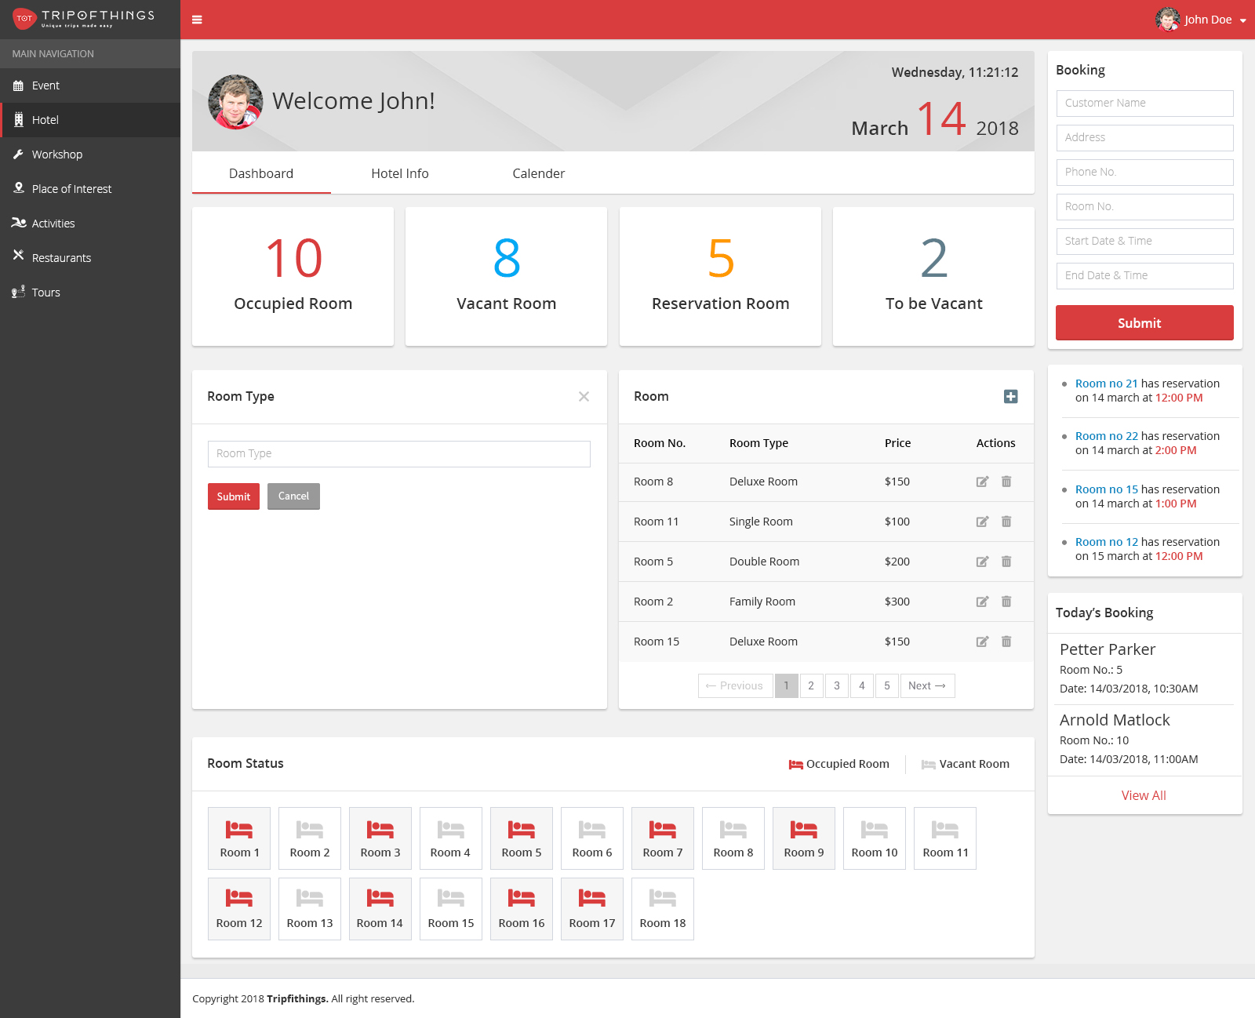

Image 3 : Room Type

## Room

This panel will contain the list of all rooms in different categories available in in the hotel. This list will show the **Room No., Room Type, Price** & **edit delete actions.** By clicking on **+ (plus icon)** at right top corner in this panel , it will show a form to add a new room. The Add form will consist of following fields :

* **Room No. :** This will be input text field room no.
* **Room Type** : A dropdown list of categories defined in Room Type panel.
* **Price** : It will be a input text field to defined the price of this specific room.

After clicking on submit button, the record will be save. By clicking edit icon, it will allow to update the particular room detail. Delete icon will allow to remove the room record from the list.

Pagination will be there at bottom of this panel to move on next & previous records.

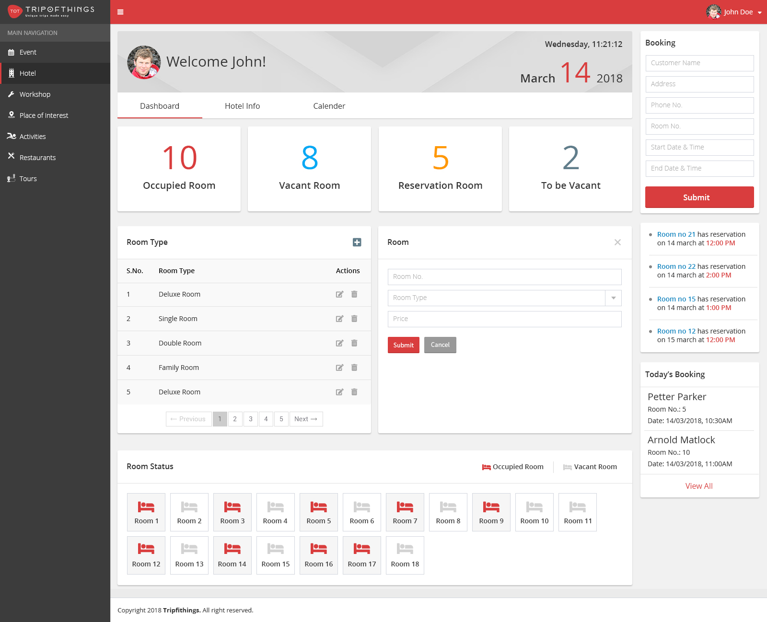

Image 4: Room

## Room Status

This panel will show the all rooms as icon in terms of **Vacant Room** or Occupied. The status of rooms will shown as of current date.

Both these status will be coloured as Gray & Red to show the status vacant or occupied respectively & same for the bed icons.

Image 5: Room

# Hotel Info

This tab will allow user to manage basic information belong to hotel. This form store the following information :

* **Hotel Name :** Complete name of Hotel
* **Address :** Complete address of Hotel
* **Phone Number :** An input text field to store phone number.
* **Main Image** : A file upload feature, to store banner image of particular hotel.
* **Breakfast included** : An option either **Yes** or **No** , by means does hotel include breakfast as complementary?
* **Overview :** It will be a WYSIWYG editor, which will allow user to store rich text content.
* **Seven Days :** These are weekdays which show the hotel’s working/opening days. All days have a checkbox in front , checked box will mark the working day & unchecked is mark as off.

User can also save the opening & closing time of hotel. These timings will applicable on all working days. For example **Opening Time** as 07:30 AM & **Closing Time** as 09:30 PM will be common for Monday, Tuesday & so on.

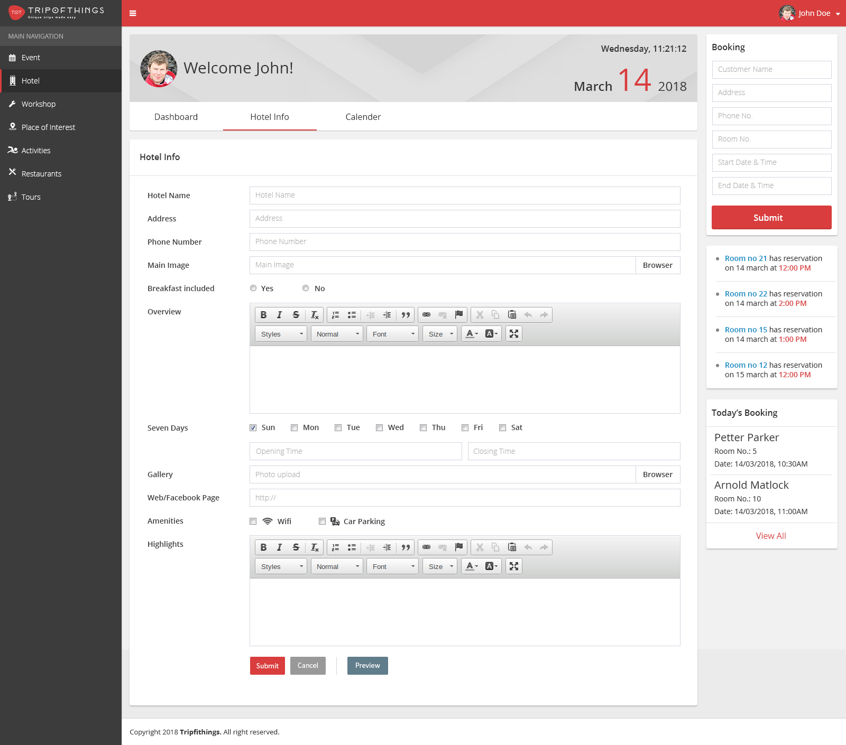

Image 6: Hotel Info

* **Gallery :** This option will allow to upload multiple photograph to show the different section of hotel like Rooms, cafetaria, reception ect.
* **Web/ Facebook Page :** This will be a input text field, which will store either website link or facebook page link.
* **Amenities**: It will be options of facilities , does hotel have or not. These feature are may be like : Wi-fi , car parking etc. These features will be show along with checkbox, checked feature will be use to show at front.
* **Highlights :** It will be a WYSIWYG editor, which will allow user to store rich text content.

After submit it will be save all information. The preview button will allow to see a real time view of these information on a single page. By clicking on cancel all modify or added data will be discard.

# Calendar

This tab will show the all booking as on current month in various date range. The calendar will show the complete month & if a booking occur in any date of current month that will be appear as strip begin from booking’s start & end as on end date.

There will be a filter option for rooms, user can filter the booking for a particular room by selecting it from the dropdown list. By default **All** optionwill be selected, which will show the bookings of all rooms.

In calendar we have option to view the booking as week wise or as day wise and the backward - forward arrow will allow to move calendar previous & next month , week or day in respective views.  
  
When **All** option will be selected :

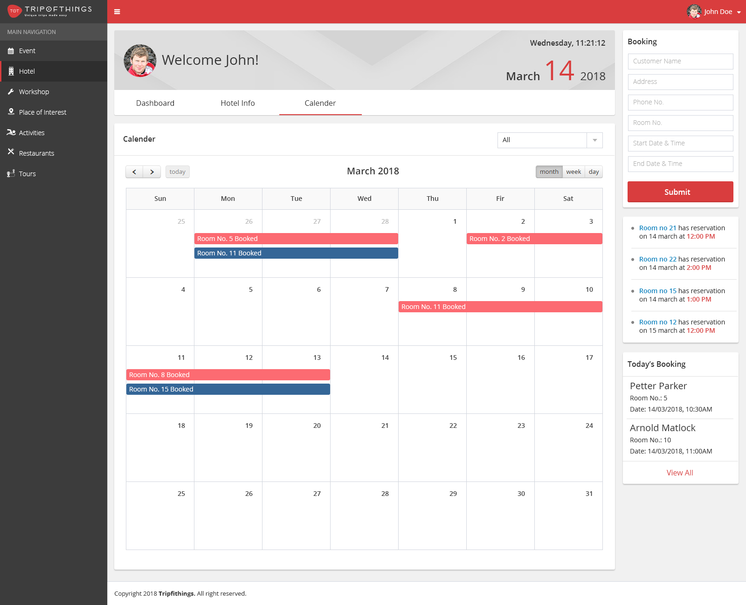Image 7: Calendar -i

When **a specific room** will be selected :

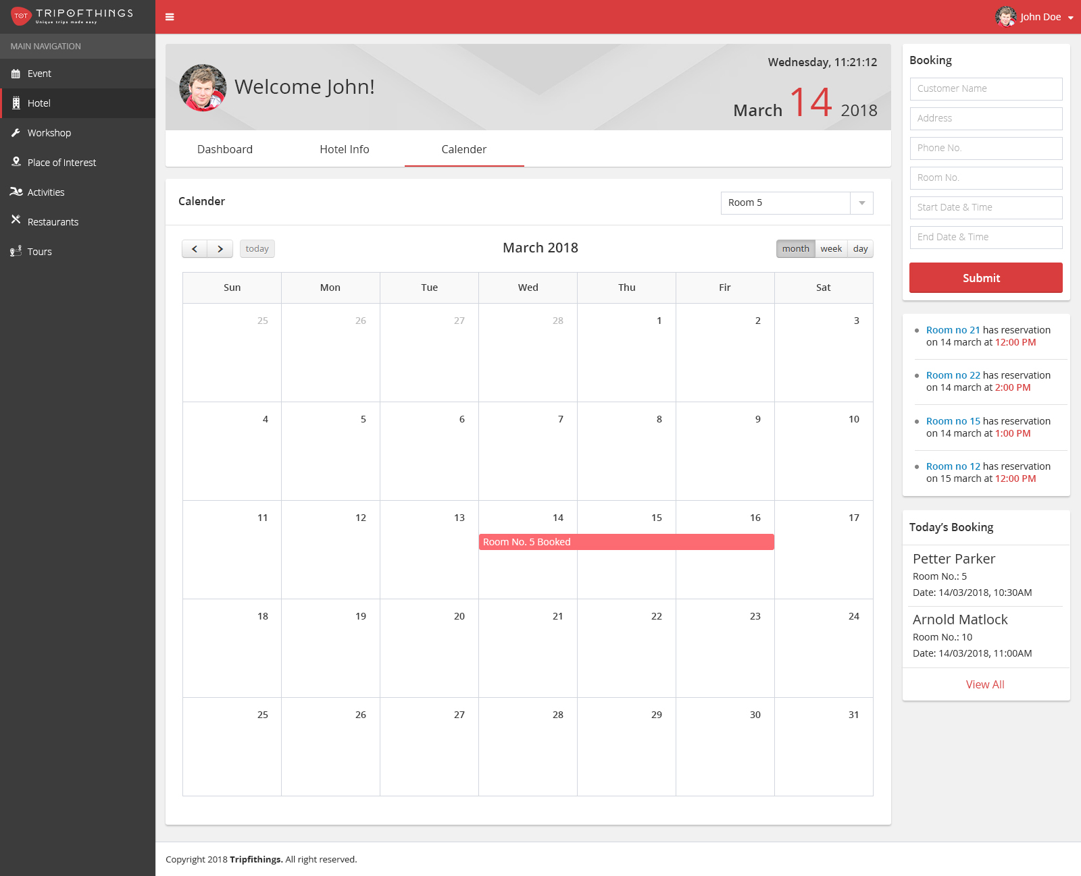

Image 8: Calendar -ii

# Finance

## Revenue & commission Statistics Tiles

There will be four tiles having the statistics data related to restaurant’s earning revenues & paid commision .These tiles show the statistics of restaurant till now. It will show the following information :

* **Forecast Revenue:** This is calculated amount of revenue as forecast and depends on previous bookings. This will show to possible earnings of restaurant.
* **Forecast Commission** : This is calculated amount of commission as forecast and it depends on previous bookings. This will show to possible payment by the restaurant.
* **Actual Revenue:** This is the total revenue earned by restaurant till the date.
* **Actual Commission**  : This is the total commission paid by restaurant till the date.
* **No Show Number :** This is the count of customer who were booked but not appeared till schedule booking time elapsed .
* **Today’s Invoice :** This it the total number of invoices generated as on current date.

Along with above statistics date at Finance Tab, it will also show graphical information for **Actual Revenue**, **Actual Commission** & **No Show Number.** These information as display in bar graph.

* **Actual Revenue:** It will show earning amount in US dollar at Y axis & last six date of current running month.
* **Actual Commission:** Same like **actual revenue,** It will also show amount in US dollar at Y axis & last six date of current running month for the paid commission.
* **No Show Number:** This chart will display the **No Show Number** of customer**.** At Y axis it will show the count of customer & last six date of current running month.

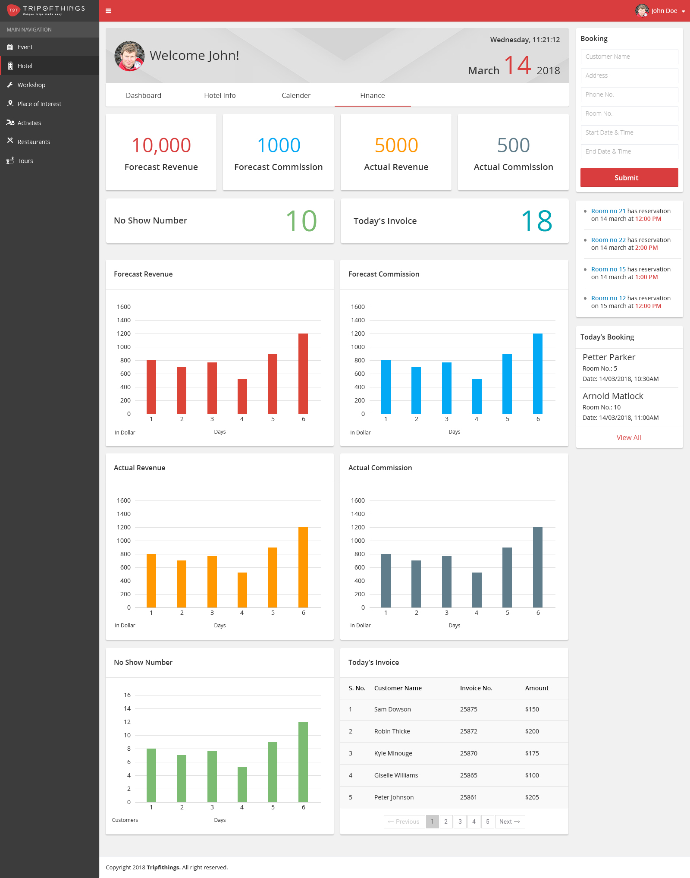Image 9: Finance

## Finance Invoice

## This tab will show the detail information of booking invoice. It will show after Submit new booking in right section of Booking Form.

It will show the following information:

**Billed To**: Name and address information of the customer.

**Invoice Number**: Invoice number of booking

**Date Of Issue**: Date of invoice issued in (DD/MM/YYYY) format.

**Invoice Total**: Total amount of generated invoice (including tax).

Detail section of invoice will show the list of booking rooms with **Room Category**, **Room Number**, **Amount.**

Admin user can **Print** the following invoice or **save as pdf** for future use by clicking on below buttons.

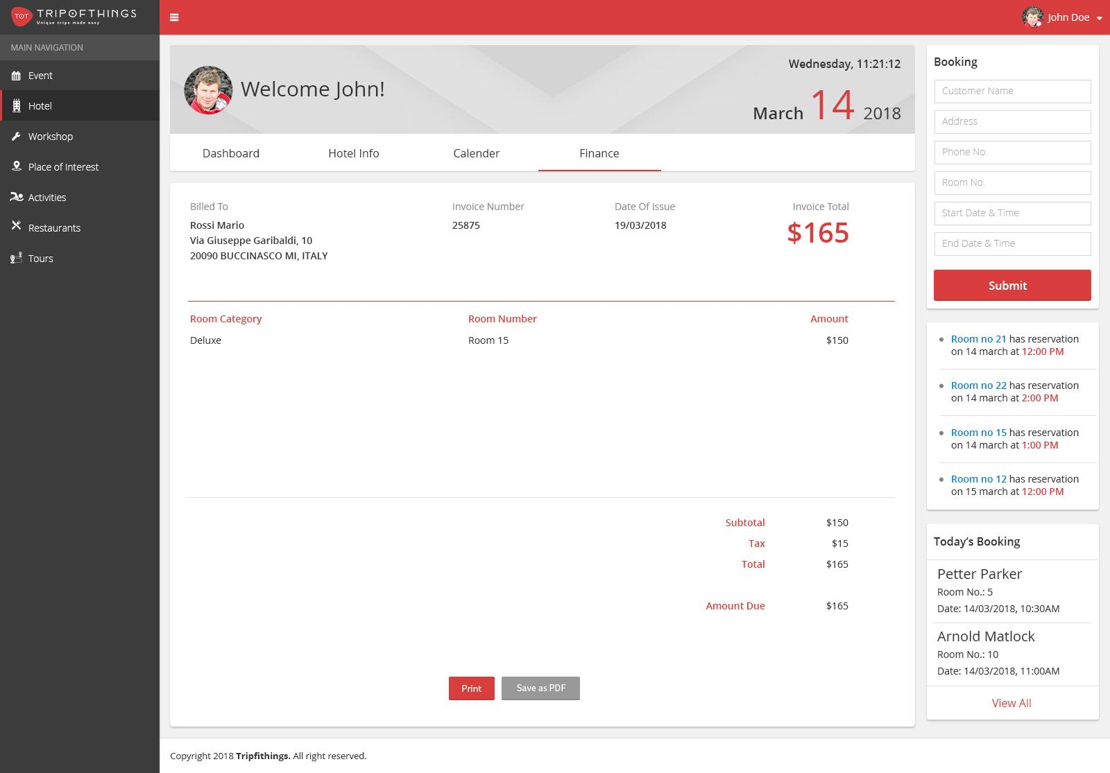

Image 10: (booking_view.jpg)

# Email

# Email Inbox

This tab will allow admin to view and manage email receive from users and site. Admin user can sort and select email detail via click on left side list. In the right side email detail section will show **subject, from name and email address, date and time, and detail** of the received email.

Admin user can reply to sender forward this to other user or delete the current email by top action of the email detail bar.

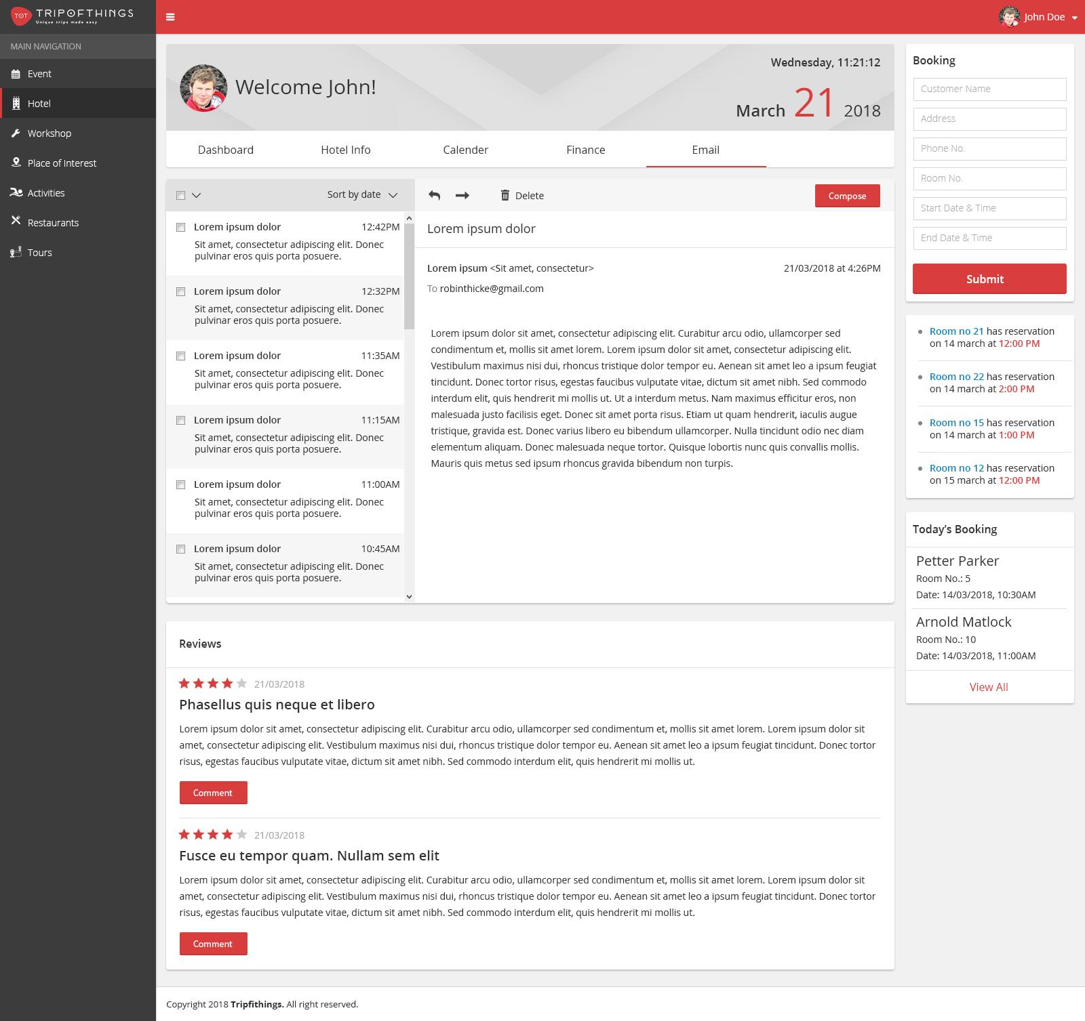

Image 11: (email.jpg)

Admin User can **compose** new email to users by clicking top right **“Compose”** action button.

In **compose email** section admin user will have option to select email address **from** dropdown when by which email will send. In **to,** **subject,** and **WYSIWYG editor** where user will enter the email address and subject for compose email, which will allow user to store rich text content.

After click on **Send** button, email is sent to selected email addresses and section is reset to “Email Inbox”, where list of all received email show.

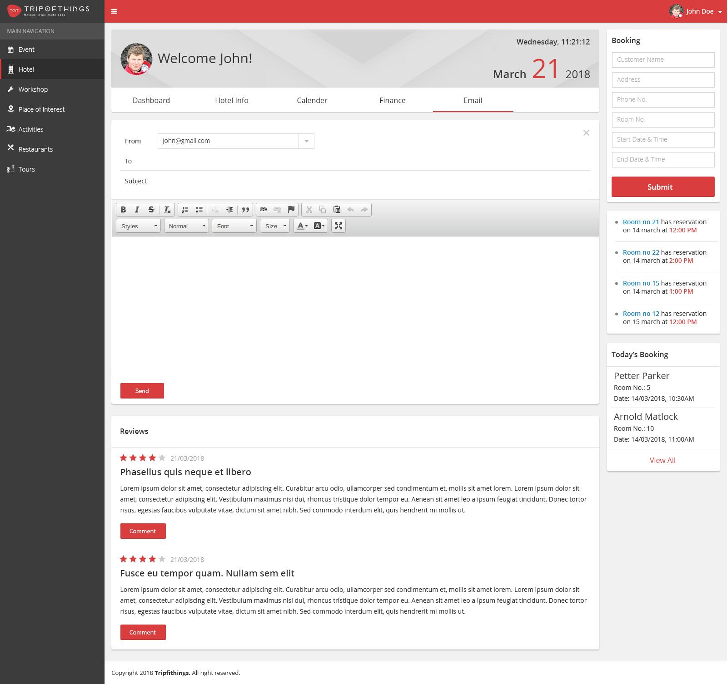

Image 12: (email_b.jpg)

# Review section

Site review section will show all reviews received by site front end, which show **reating, date, title and detail of review.** Admin user can reply comment on the particular review by **“Comment”** button below detail of review.

When admin user click on **“Comment”** button, the text editor will show where admin user can add comment to review and submit to it.

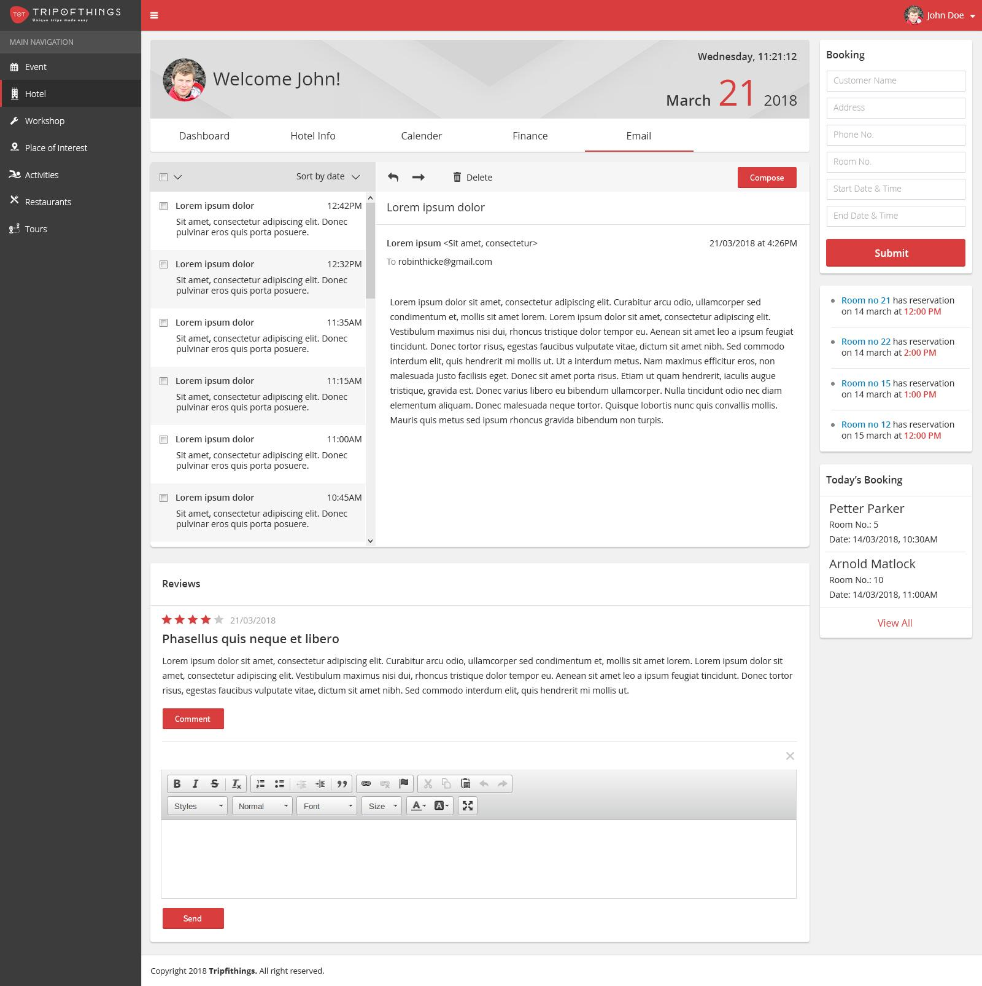

Image 13: (email_c.jpg)

# Configuration

# Merchant

Merchant tile show the list to all marchent list on site. New merchant will be add by clicking on **+ (plus icon)** at right top corner in this tile. The Add form will consist of **name, address, phone number, email** and **amount** fields. After clicking on submit button, the new merchant will be save and add to the Merchant list.

Pagination will be there at bottom of this panel to move on next & previous records.

# Email Template

Email templates tile show the list to all email template used for different topics in site. By clicking on **+ (plus icon)** at right top corner in this tile , it will show a form to add a new template. The Add form will consist of **Topic** field **template detail** is WYSIWYG editor, which will allow user to store rich text content.

After clicking on submit button, the record will be save.

Pagination will be there at bottom of this panel to move on next & previous records.

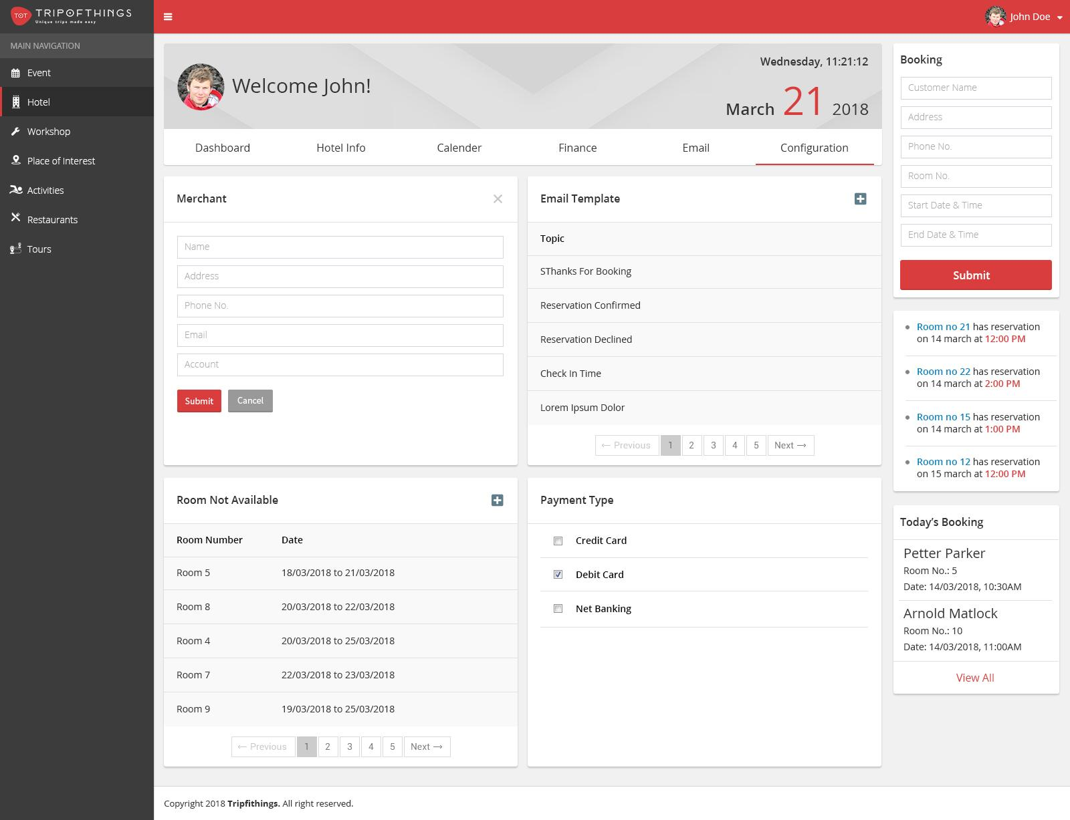

Image 14: (configuration_b.jpg)

# Room Not Available

This tile will show the list of rooms with **room number** and **date** of all unavailable rooms. Pagination will be there at bottom of this panel to move on next & previous records. By clicking on **+ (plus icon)** at right top corner in this tile , it will show a form to add a new room to this list.

The Add form will consist of **room number**, **start date** and **end date**.

After clicking on submit button, the record will be save and room is added to unavailable list.

# Payment Type

This tile will show configuration setting for payment type available for front payment.

Currently admin user can select options from **credit card**, **debit card** and **net banking**.

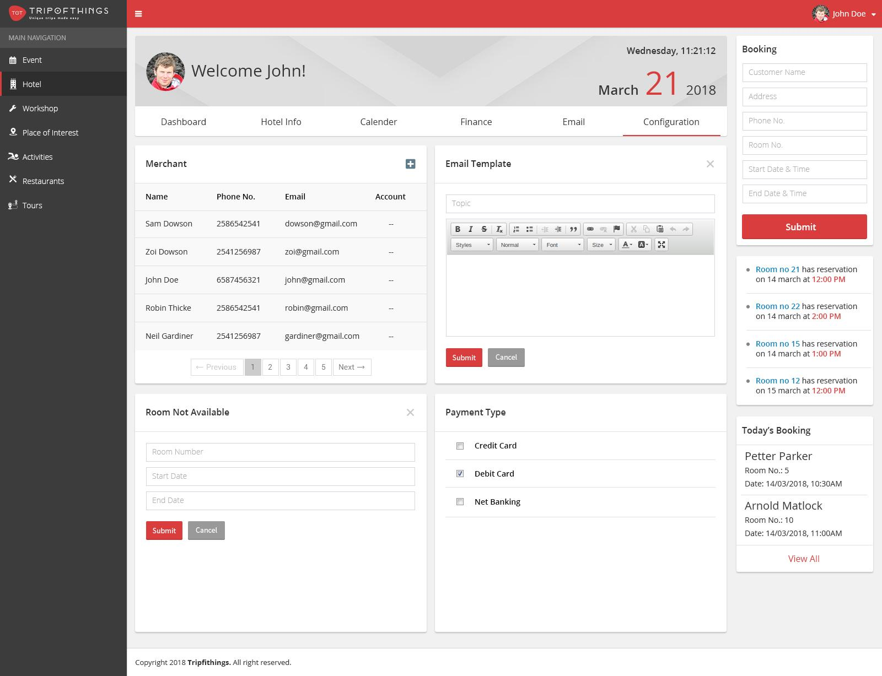

Image 15: (configuration.jpg)